11.2 Reaction of acids and bases
Name: ____________________ Class: ____________________ Due date:
1. A gas is escaping from a pipe in a chemical plant.
A chemist tests this gas and finds that it is alkaline.
What is this gas? （ ）
A ammonia
B chlorine
C hydrogen
D sulfur dioxide

2. Dilute hydrochloric acid is added to a solid, S.
A flammable gas, G, is formed. Gas G is less dense than air.
What are S and G? （ ）
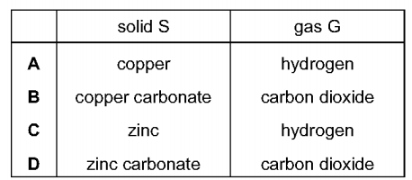

3. The diagram shows two substances, X and Y, being heated together.
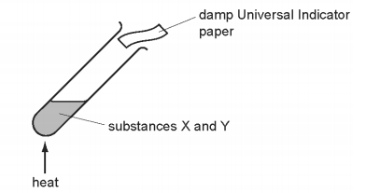
The Universal Indicator paper turns blue during the experiment.
What are substances X and Y? （ ）
A ammonium nitrate and hydrochloric acid
B ammonium nitrate and sodium hydroxide
C sodium carbonate and hydrochloric acid
D sodium carbonate and sodium hydroxide

4. Which statement about the reaction of acids is correct? （ ）
A They react with ammonium salts to form a salt and ammonia only.
B They react with metal carbonates to give a salt and carbon dioxide only.
C They react with metal hydroxides to give a salt and water only.
D They react with metals to give a salt, hydrogen and water only.

5. Which are properties of an acid? （ ）
1 reacts with ammonium sulfate to form ammonia
2 turns red litmus blue
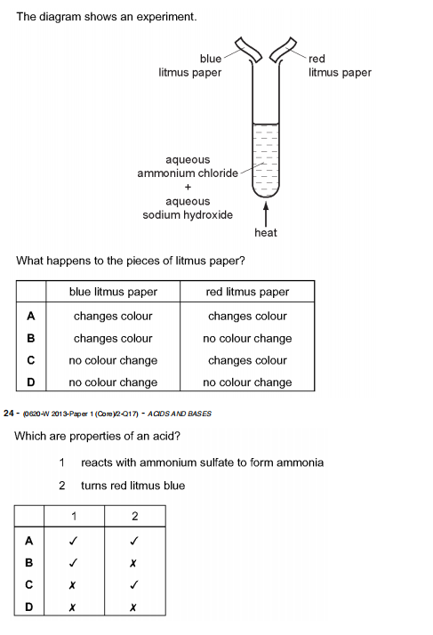
6. The diagram shows an experiment.
What happens to the pieces of litmus paper? （ ）
7. Which statements about alkalis are correct? （ ）
1 When reacted with an acid, the pH of the alkali increases.
2 When tested with litmus, the litmus turns blue.
3 When warmed with an ammonium salt, ammonia gas is given off.
A 1, 2 and 3 B 1 and 2 only C 1 and 3 only D 2 and 3 only

8. Which method can be used to obtain ammonia from ammonium sulfate? （ ）
A Heat it with an acid.
B Heat it with an alkali.
C Heat it with an oxidising agent.
D Heat it with a reducing agent.

9. Which statement is not correct? （ ）
A When a base reacts with an ammonium salt, ammonia is given off.
B When an acid reacts with a base, neutralisation takes place.
C When an acid reacts with a carbonate, carbon dioxide is given off.
D When the acidity of a solution increases, the pH increases.

10. Which reaction is not characteristic of an acid? （ ）
A It dissolves magnesium oxide.
B It produces ammonia from ammonium compounds.
C It produces carbon dioxide from a carbonate.
D It produces hydrogen from zinc metal.

11. Which property is not characteristic of a base? （ ）
A It reacts with a carbonate to form carbon dioxide.
B It reacts with an acid to form a salt.
C It reacts with an ammonium salt to form ammonia.
D It turns universal indicator paper blue.

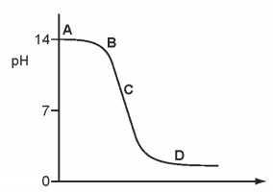
1. The graph shows how the pH changes as an acid is added to an alkali.
acid + alkali → salt + water
Which letter represents the area of the graph where both acid and salt are present? （ ）

2. Carbonic acid is a weak acid formed when carbon dioxide dissolves in water.
What is the pH of the solution? （ ）
A 1 B 5 C 7 D 9
3. Dilute hydrochloric acid is added to a solid, S.
A flammable gas, G, is formed. Gas G is less dense than air.
What are S and G? （ ）

3. Which statement about the reaction of acids is correct? （ ）
A They react with ammonium salts to form a salt and ammonia only.
B They react with metal carbonates to give a salt and carbon dioxide only.
C They react with metal hydroxides to give a salt and water only.
D They react with metals to give a salt, hydrogen and water only.

4. What is not a typical characteristic of acids? （ ）
A They react with alkalis producing water.
B They react with all metals producing hydrogen.
C They react with carbonates producing carbon dioxide.
D They turn blue litmus paper red.

5. Ethanoic acid is a weak acid. Hydrochloric acid is a strong acid.
$1.0 {\text{mol/dm}}^{3}$$1.0 {\text{mol/dm}}^{3}$Which statements are correct? （ ）
1 Ethanoic acid molecules are partially dissociated into ions
2 ethanoic acid has higher pH than hydrochloric acid
3 Ethanoic acid is always more dilute than hydrochloric acid
A 1 and 2 B 1 and 3 C 2 and 3 D 1，2 and 3
6. Solutions of acid R and acid S have the same concentration.
The same volume of each acid at the same temperature is reacted with the same mass of magnesium ribbon.
The volume of hydrogen produced is measured.
The results are shown.
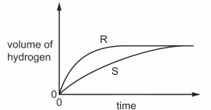
Which statement about the reactions is correct? （ ）
A Acid S reacts faster than acid R.
B The final volume of hydrogen produced in each reaction is different.
C Acid R is a stronger acid than acid S.
D Acid S is a stronger acid than acid R.

7. The graph shows how the pH changes as an acid is added to an alkali.
acid + alkali → salt + water
Which letter represents the area of the graph where both acid and salt are present? （ ）
8. What is not a typical characteristic of acids? （ ）
A They react with alkalis producing water.
B They react with all metals producing hydrogen.
C They react with carbonates producing carbon dioxide.
D They turn blue litmus paper red.

9. Please complete the following chemical reactions
a. NaOH + HCl → +
b. Ca(OH)₂ + H₂SO₄ → +
c. Mg + HNO₃ → +
d. Zn + HCl → +
e. CaCO₃ + HCl → +
f. Na₂CO₃ + H₂SO₄→ +

